# **Data Module Reference – Wordpress api and store explained**

[**https://www.udemy.com/course/gutenberg/learn/lecture/30450844#questions/18131256/**](https://www.udemy.com/course/gutenberg/learn/lecture/30450844%23questions/18131256/)

<https://developer.wordpress.org/block-editor/reference-guides/data/>

All of the next items are wordpress data stores from wp.data:

* [**core**: WordPress Core Data](https://developer.wordpress.org/block-editor/reference-guides/data/data-core/) – all core data store
* [**core/annotations**: Annotations](https://developer.wordpress.org/block-editor/reference-guides/data/data-core-annotations/)
* [**core/block-directory**: Block directory](https://developer.wordpress.org/block-editor/reference-guides/data/data-core-block-directory/)
* [**core/block-editor**: The Block Editor’s Data](https://developer.wordpress.org/block-editor/reference-guides/data/data-core-block-editor/) – the block data store, will allow us to get all info regarding **Current Post** our blocks
* [**core/blocks**: Block Types Data](https://developer.wordpress.org/block-editor/reference-guides/data/data-core-blocks/) – the block data store, will allow us to get all info regarding **ALL** our blocks
* [**core/customize-widgets**: Customize Widgets](https://developer.wordpress.org/block-editor/reference-guides/data/data-core-customize-widgets/)
* [**core/edit-post**: The Editor’s UI Data](https://developer.wordpress.org/block-editor/reference-guides/data/data-core-edit-post/) – the UI of the post editor
* [**core/edit-site**: Edit Site](https://developer.wordpress.org/block-editor/reference-guides/data/data-core-edit-site/)
* [**core/edit-widgets**: Edit Widgets](https://developer.wordpress.org/block-editor/reference-guides/data/data-core-edit-widgets/)
* [**core/editor**: The Post Editor’s Data](https://developer.wordpress.org/block-editor/reference-guides/data/data-core-editor/) – all of our post data, like getting the current post id or post type
* [**core/keyboard-shortcuts**: The Keyboard Shortcuts Data](https://developer.wordpress.org/block-editor/reference-guides/data/data-core-keyboard-shortcuts/)
* [**core/notices**: Notices Data](https://developer.wordpress.org/block-editor/reference-guides/data/data-core-notices/) – create noticesa such as error messages or warnings
* [**core/nux**: The NUX (New User Experience) Data](https://developer.wordpress.org/block-editor/reference-guides/data/data-core-nux/)
* [**core/preferences**: Preferences](https://developer.wordpress.org/block-editor/reference-guides/data/data-core-preferences/)
* [**core/reusable-blocks**: Reusable blocks](https://developer.wordpress.org/block-editor/reference-guides/data/data-core-reusable-blocks/)
* [**core/rich-text**: Rich Text](https://developer.wordpress.org/block-editor/reference-guides/data/data-core-rich-text/)
* [**core/viewport**: The Viewport Data](https://developer.wordpress.org/block-editor/reference-guides/data/data-core-viewport/)

@**wordpress**/**data Store**

We can use any store from the above with data.select for pulling data or data.dispatch to send data.

**wp.data.select('core'):**

will allow us to rquest data from the api

example: **getEntityRecords**:

wp.data.select('core').getEntityRecords('ybd/v1', 'threats-short-light-data')

will allow us to fethch data from the REST api

**wp.data.dispatch('core')** :

Disptch will alow us to sent actions to the api,

for example: **addEntities** for creating a new rest api endpoint for react and Gutenberg,

**deleteComment** for deleating posts comments

Example:

**wp.data.select('core/blocks')** will show us all of the methods we can use to fetch data from the core/block store

**wp.data.dispatch('core/blocks')** will allow us to see al methos we can use to change data via api on the server

**wp.data.select('core/block-editor')**.getBlockCount() – will get us the total number of block in the current post only

**wp.data.select('core/block-editor').**getBlocks() – will retuen the data for all of our post blocks:

*(2) [{…}, {…}]*

**0**:

**attributes**: {content: 'post 3', dropCap: false}

**clientId**: "081ab22f-d95a-4fed-9e59-66c9f8505874"

**innerBlocks**: []

**isValid**: true

**name**: "core/paragraph"

**originalContent**: "<p>post 3</p>"

**validationIssues**: []

[[Prototype]]: Object

**1**: {clientId: '1113e99b-dfe9-4bb0-b791-f174a431544e', name: 'ybd-functions/ybd-display-custom-post-block', isValid: true, attributes: {…}, innerBlocks: Array(0)}

**length**: 2

[[Prototype]]: Array(0)

If we use the "dispatch" we can ask for changes in our post blocks, E.G:

wp.data.dispatch('core/block-editor').removeBlock('6a26d2f9-fab8-4398-9236-b09ac91e7479')

this will remove a block with the **clientId** ('6a26d2f9-fab8-4398-9236-b09ac91e7479') from the editor

**wp.data.select('core/editor')** will allow us to retrive data for our post and blocks

**wp.data.dispatch('core/editor')** will allow us to edit or save our post like so:

*wp.data.dispatch('core/editor').****editPost(…)***

*wp.data.dispatch('core/editor').****updatePost(…)***

**wp.data.dispatch('core/edit-post)** will allow us to get data regaring our block editor UI,

Example, Lets say we want to check if the editor sitebar is open or close:

We will use: isEditorSidebarOpened: ƒ ()

wp.data.select('core/edit-post').isEditorSidebarOpened() – will return "true/False" value

if we will use the wp.data.dispatch we can close or open the sidebar:

wp.data.dispatch('core/edit-post').togglePublishSidebar()

**wp.data.dispatch('core/notices') will allow us to print messages to the editor screen,**

example – print an error message notice:

wp.data.dispatch('core/notices').createErrorNotice('this is my error message!!!!')

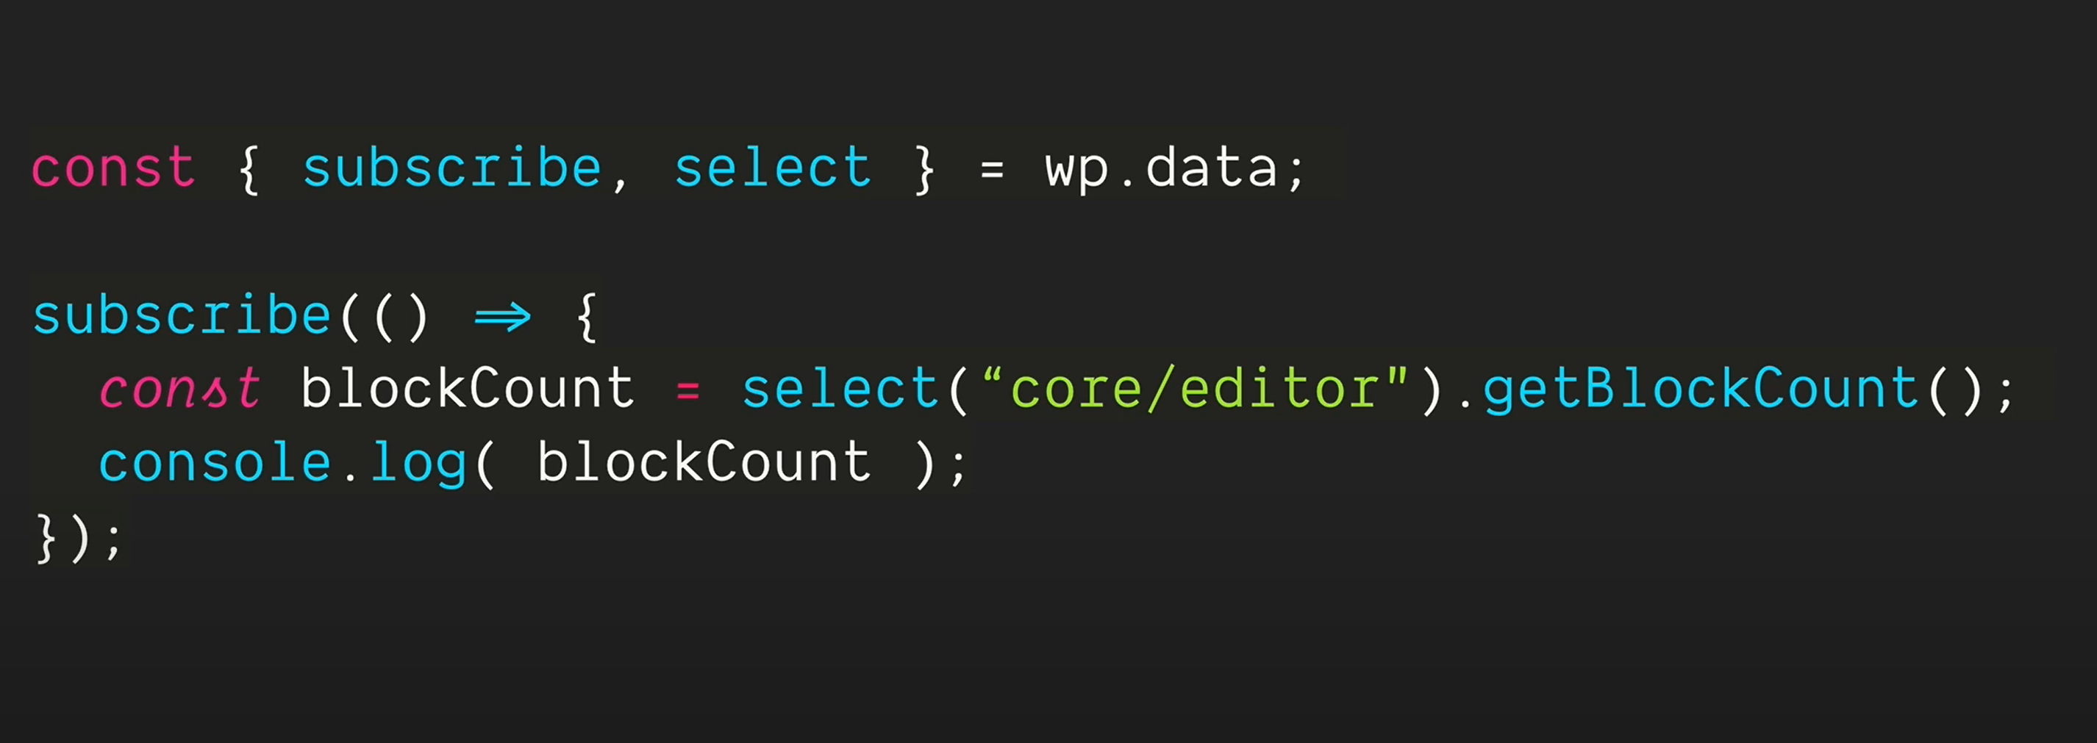

The subscribe() function will be triggered every time the sate of the variable inside it (blockcount) is chaning.

So we can add this function once and it will run every time there is a change in the variable it is holds.

https://www.youtube.com/watch?v=OQczO6VOMkY